

**BCSE203E- Web Programming**

**Assignment**

*Topics –, HTML Block and Inline Elements <div> and <span> and Semantic HTML.*

**Activity 1:**

* A description of yourself in minimum 3 paragraphs and justify the text content
* Highlight the most important word(s) and infer the differences of bold, strong, emphasize.
* Use background colours and text colours appropriately for a good design.
* Add your image in left corner of the first paragraph

Code:

<!DOCTYPE html>

<html lang="en">

<head>

<meta charset="UTF-8">

<meta name="viewport" content="width=device-width, initial-scale=1.0">

<title>About Me</title>

</head>

<body>

<div style="font-family: Arial, sans-serif; line-height: 1.6; max-width: 600px; margin: 20px auto; background-color: #f9f9f9; padding: 15px; border: 1px solid #ddd; border-radius: 8px;">

<div style="overflow: hidden; margin-bottom: 20px;">

<img src="profile.jpg" alt="My Photo" style="float: left; margin-right: 15px; width: 100px; height: 100px; border-radius: 50%; border: 2px solid #ccc;">

<p style="text-align: justify;">Hello! My name is <strong>Midhul kiruthik</strong>, and I am a passionate web developer with a love for creating clean and user-friendly designs. Over the years, I have honed my skills in front-end development, making websites that not only look great but also function seamlessly.</p>

</div>

<p style="text-align: justify;">In my free time, I enjoy exploring new technologies and keeping up with the latest trends in web development. I believe in the power of <strong>strong</strong> collaboration and teamwork, which have always helped me grow professionally and personally. When I'm not coding, I indulge in reading books and hiking in nature.</p>

<p style="text-align: justify;">My ultimate goal is to create meaningful projects that make a difference. I am always looking for ways to <em>improve</em> and contribute to the tech community. If you're interested in working with me or just want to connect, feel free to reach out!</p>

<p>

<strong style="color: blue;">Note:</strong>

The <strong>strong</strong> tag visually bolds text and adds semantic importance, while <b>bold</b> only affects styling. Similarly, the <em>emphasize</em> tag italicizes text and implies emphasis, while <i>italic</i> is purely stylistic.

</p>

</div>

</body>

</html>

Output:

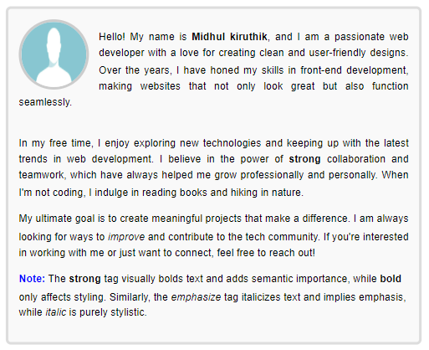

**Note: Incorporate HTML Block <*div>* and Inline Elements *<span>***

**Activity 2: Semantic html**

Design a web page of your choice “*myindex.html*” and include the following information as follows.

* Home Page - Short Descriptions about your theme.
* Navigation page- include all the activity listed as per module 2 (all html documents)
* Blog Page – Photos/ videos/ hyperlinks
* Contact us – Use your intuitive approach and add the form fields for a contact us page in the footer.

Code;

<!DOCTYPE html>

<html lang="en">

<head>

<meta charset="UTF-8">

<meta name="viewport" content="width=device-width, initial-scale=1.0">

<title>My Index Page</title>

</head>

<body style="font-family: Arial, sans-serif; line-height: 1.6; margin: 0; padding: 0;">

<header style="background: #333; color: #fff; text-align: center; padding: 10px 0;">

<h1>Welcome to My Website</h1>

<p>A simple semantic HTML design</p>

</header>

<nav style="background: #555; color: #fff; text-align: center; padding: 10px;">

<a href="myindex.html" style="color: #fff; margin: 0 15px; text-decoration: none;">Home</a>

<a href="navigation.html" style="color: #fff; margin: 0 15px; text-decoration: none;">Navigation</a>

<a href="blog.html" style="color: #fff; margin: 0 15px; text-decoration: none;">Blog</a>

<a href="#contact-us" style="color: #fff; margin: 0 15px; text-decoration: none;">Contact Us</a>

</nav>

<main style="padding: 20px; background: #f9f9f9;">

<section>

<h2 style="color: #333;">About the Website</h2>

<p>This website is designed to demonstrate the use of semantic HTML and includes a home page, navigation, blog, and contact us page. Explore and enjoy!</p>

</section>

</main>

<footer id="contact-us" style="background: #333; color: #fff; text-align: center; padding: 20px;">

<h3>Contact Us</h3>

<form style="display: flex; flex-direction: column; align-items: center;">

<input type="text" placeholder="Your Name" style="margin: 5px; padding: 10px; width: 80%; max-width: 400px;">

<input type="email" placeholder="Your Email" style="margin: 5px; padding: 10px; width: 80%; max-width: 400px;">

<textarea placeholder="Your Message" style="margin: 5px; padding: 10px; width: 80%; max-width: 400px; height: 100px;"></textarea>

<button type="submit" style="margin: 5px; padding: 10px; width: 80%; max-width: 400px; background: #555; color: #fff; border: none; cursor: pointer;">Send</button>

</form>

</footer>

</body>

</html>

Output:

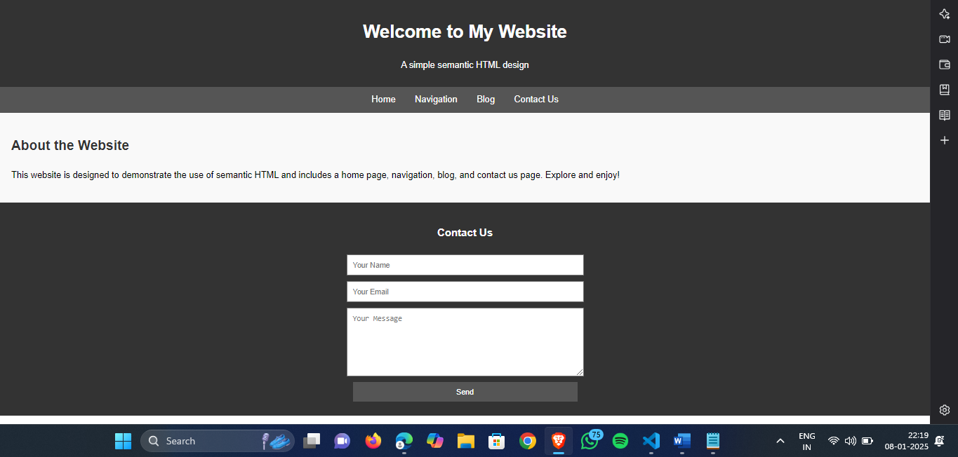

**Activity 3: Create the following layout pages using CSS and div**

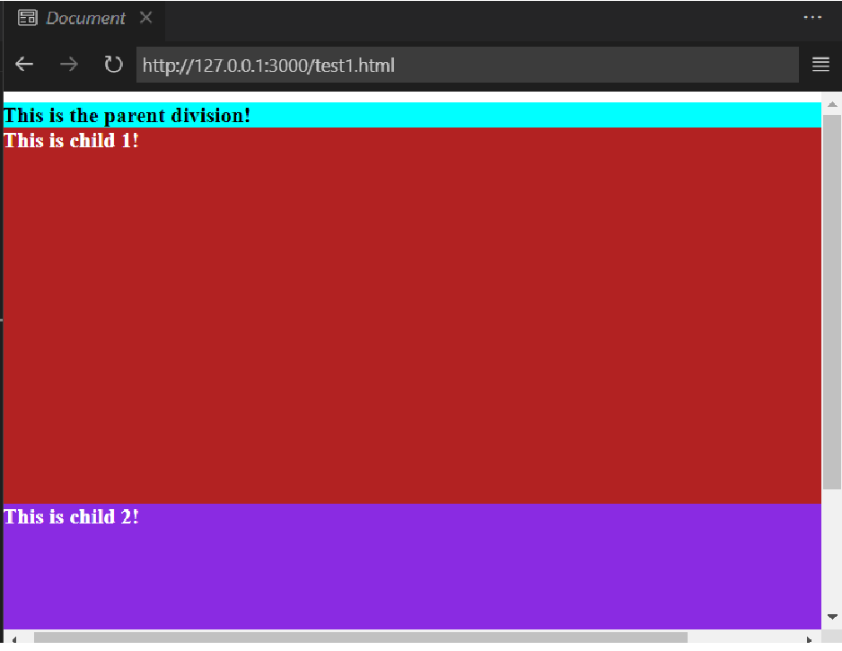

Code:

<!DOCTYPE html>

<html lang="en">

<head>

<meta charset="UTF-8">

<meta name="viewport" content="width=device-width, initial-scale=1.0">

<title>Division Layout</title>

</head>

<body>

<!-- Parent Division -->

<div style="background-color: cyan; height: 400px;">

<b>This is the parent division!</b>

<!-- Child Division 1 -->

<div style="background-color: maroon; color: white; height: 300px;">

This is child 1! </div>

<!-- Child Division 2 -->

<div style="background-color: purple; color: white; height: 100px;">

This is child 2!

</div>

</div>

</body>

</html>

Output:

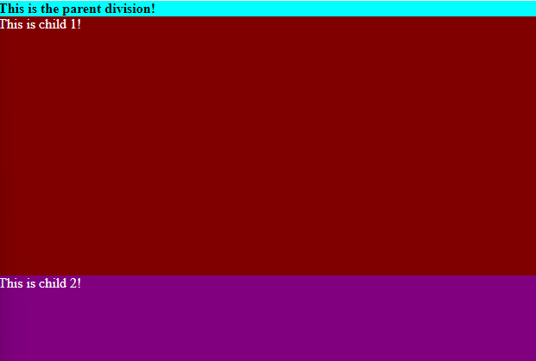

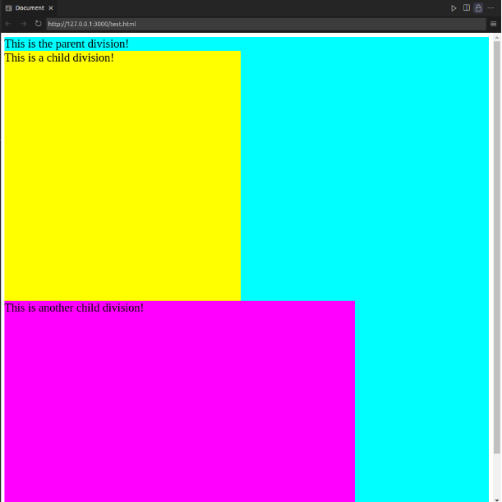

Code:

<!DOCTYPE html>

<html lang="en">

<head>

<meta charset="UTF-8">

<meta name="viewport" content="width=device-width, initial-scale=1.0">

<title>Division Layout</title>

</head>

<body>

<!-- Parent Division -->

<div style="background-color: cyan; height: 418px; width: 500px;">

This is the parent division!

<!-- First Child Division -->

<div style="background-color: yellow; width: 250px; height:250px; ">

<p style="margin: 0;">This is a child division!</p>

</div>

<!-- Second Child Division -->

<div style="background-color: magenta; width: 330px; height: 150px;">

<p style="margin: 0;">This is another child division!</p>

</div>

</div>

</body>

</html>

Output:



